**Project Report**

**on**

**Applications of Chatbot**



**Submitted By Guide:**

**Hemangi K. Chhaya __________________**

**Reg. No. : 06-0245-2017 Dr.Y.R.Ghodasara**

**Semester: VII (Unit head and Dean-CAIT, AAU)**

**College of Agricultural Information Technology**

**Anand Agricultural University**

**Anand - 388 110.**

**Certificate**

This is to certify that **Hemangi Chhaya** of 7th semester have satisfactorily completed the Project work titled **Applications of Chatbot** as a Project requirement of the Bachelor of Technology in Agricultural Information Technology of the Anand Agricultural University , Anand.

**Dr.Y.R.Ghodasara**

(Unit head and Dean-CAIT, AAU, Anand)

**College of AIT**

# Acknowledgement

**“Gratitude is a feeling which is more eloquent than words, more tranquil than silence…”**

The successful completion of a project is generally not an individual effort. It is an outcome of the collective efforts of a number of persons, each having own importance to the objective. This session is a vote of thanks to all those persons who have directly or indirectly added in their own specials way towards the completion of this project.

I heartily thankful to **Dr.Y.R.Ghodasara** for his time, suggestions, support and guidance at each and every step of this project and without whom, this project would have been a tough task.

With this it would be a very difficult task without my classmates who were there at each time for the functioning and testing of this website. Thanks to all of them.

Thank you to **Dr.Y.R.Ghodasara** (Unit head and Dean-CAIT, AAU, Anand) for providing this platform which helped in the development of my technical skills.

At last I owe a huge debt of thanks to a large number of people without whom none of this would have been possible.

# Abstract

In Seventh semester of CAIT, I have been developing a project is called “**Applications of Chatbot**”. It project is study of chatbot engine available online and compare those applications for different platform.

**Index**

Contents

1. Applications of Chatbot 7

2. Introduction 8

3. Purpose 9

4. Objectives 10

5. Scope 10

6. Technology and tools used 10

6.1 Hardware Configuration 10

6.2 Software Configuration 10

7. Chatbot Introduction: 10

7.1 Platforms 11

7.2 Communication Mechanisms 11

7.3 Development 11

7.4 Programming Language 12

7.5 Data Storage 12

7.6 Classification of chatbots 12

7.7 Functional Requirements 14

7.8 Non-functional Requirements 14

7.7 Advantages of Using Chatbots 15

7.8 Limitations of the chatbots 15

8. Snatchbot 16

8.1 Natural language processing 17

8.2 Snatchbot Platform Features 17

9. FlowXo 17

9.1 How does Flow XO work? 18

9.1.1 Create your chatbot 18

9.1.2 Build your workflows 18

9.1.3 Integrate your apps 18

9.2 Flow Xo Platform Features 18

10. Chatteron 19

10.1 ChatterOn Platform Features 19

10.1.1 Easy to build 19

10.1.2 Monetize 20

10.1.3 Bot Builder 20

10.1.4 End-to-end Solution 20

10.1.5 Rich Content 20

10.1.6 Business Integration 20

11. Flowchart Diagram 21

11.1 Corona Virus Information Chatbot 21

11.2 Government Exam Chatbot 22

11.3 E-Commerce 23

11.4 College Enquiry Chatbot 24

11.5 Latest News Feeder Chatbot 25

12. System Design 26

12.1 Corona virus Information Chatbot 26

12.1.1 Home Page 26

12.1.2 Starting Page 27

12.1.3 Ending Page 29

12.2 Government Exam Chatbot 30

12.2.1 Home Page 30

12.2.2 Starting Page 31

12.2.3 Ending Page 34

12.3 E-Commerce 35

12.3.1 Home Page 35

12.3.2 Starting Page 35

12.3.3 Ending Page 38

12.4 College Enquiry Chatbot 39

12.4.1 Home Page 39

12.4.2 Starting Page 40

12.4.3 Ending Page 43

12.5 Latest News Feeder Chatbot 44

12.5.1 Home Page 44

12.5.2 Starting Page 45

12.5.3 Ending Page 47

Conclusions 48

Reference 48

# Applications of Chatbot

1. Corona Virus Information Chatbot
2. Government Exam Chatbot
3. E-Commerce
4. College Enquiry Chatbot
5. Latest News Feeder Chatbot

# Introduction

|  |  |  |
| --- | --- | --- |
| **Title** | **Platform** | **Use NLP** |
| 1. Corona Virus Information Chatbot | Snatchbot | Yes |
| 1. Government Exam Chatbot | Snatchbot | No |
| 1. E-Commerce | Chatteron | No |
| 1. College Enquiry Chatbot | FlowXo | No |
| 1. Latest News Feeder Chatbot | FlowXo | No |

1. **Corona Virus Information Chatbot**

* This Chatbot is providing all corona virus information of users query. Users choose button and button clicking to information provide the Chatbot. Virtually every Chatbot platform has some form of many systems available on desktop versions. I have used in NLP (Natural Language Programming).NLP is a technological process that allows computers to derive meaning from user text inputs. In the context of chatbots, integrating NLP means adding a more human touch. If you've built a chatbot and deployed it for public use, it's likely that you've seen users attempting to ask it questions. This chatbot will help you to track important information about Corona virus (2020), including latest news, precautions and FAQ in Guajarati language.

1. **Government Exam Chatbot**

* This Chatbot is providing all Government Exam information of users query. Users choose start button click then starting the quiz. This chatbot template asks questions, keeps score of whether the answers are right or wrong and gives the result and feedback at the end.

1. **E-Commerce**

* This Bot helps you find the best deals, the latest offers, and shops based on your location. This bot provide all product with images, all product details provide the users and buy now clicking button then go to the website page and than buy now the product. This chatbot make in Chatterton platform and I have used in entity. To user write have show this product to then direct this page show the users.
* Customers love beauty products especially if they enhance their looks. However, for a business, we understand the number of challenges that come with cloths products. Whether you've launched a new item or trying to get more sales for a particular product, this chatbot template can help you choose product. Working as a personal consultant, this chatbot also convinces users to make a purchase.

1. **College Enquiry Chatbot**

* College Enquiry Chatbot provides to all information Educational templates to kids through chatbots. To all students show the college information, course details and contact the college details. Student enter merit then check the condition then show the college.

1. **Latest News Feeder Chatbot**

* This chatbot provide the different language and different sources. To provide the latest news in newspaper links, images and videos to show the all users. Then clicked more information provide to bot and end the chat.

# Purpose

* A [chatbot](https://chatbotslife.com/) can communicate with a real person behaving like a human.
* Accessible anytime
* Handling Capacity
* Flexible attribute
* Customer Satisfaction
* Personal Assistant

# Objectives

* To study different chatbot applications for different sectors.
* The objective of chat bots is to support and scale business teams in their relations with customers. It could live in any major chat applications like Facebook Messenger, Telegram, Text Messages, etc...

# Scope

* Chatbots are fully functioning, semi-autonomous systems that can assist customer service experiences and response time. The future scope of chatbots could include many benefits for enterprises, but experts say they will need to be gently nudged in the right direction for businesses to reap these benefits.
* The Chatbots developed in this project are used for basic communication with the customers.

# Technology and tools used

## 6.1 Hardware Configuration

1 GB RAM (for effective working)

Dual Core Processor (for effective working)

Software Requirement(s)

Windows 7/8/10

Google Chrome

## 6.2 Software Configuration

* Snatchbot ([SnatchBot: Free Chatbot Solutions, Intelligent Bots Service and Artificial Intelligence](https://snatchbot.me/))
* FlowXo ([Flow XO – Easy to use chatbot platform](https://flowxo.com/)
* Chatteron ([ChatterOn | Build AI Chat bots](https://www.chatteron.io/))

# Chatbot Introduction:

* This work gives a general introduction to chatbots by explaining what they are, what they can be used for and how to develop them. No previous domain-specific knowledge is required.
* At the same time not many potential users know about the existence of chatbots or about areas in which chatbots could be helpful assistance. The topic is equally unknown to developers. While the term chatbot is commonly used in media, the meaning mostly remains ambiguous. There is a need for further explanation of what chatbots are and further analysis to identify well suited applications for chatbots. Additionally to spreading knowledge about the potentials of chatbots and their use cases, more developers should be enabled to create new, innovative chatbots.
* Use cases of chatbots can be identified in existing products. Market trends and attributes of media and technology can be analyzed to find new potential scenarios for the usage of chatbots. Development is best explained by creating a real chatbot and by using it to present the general principles of the development process.

## 7.1 Platforms

* Unless software is distributed with dedicated hardware, software products are designed to be executed by and accessed through other software. The underlying software is the platform a product is created for. Products that target operating systems such as Microsoft Windows or Apple’s iOS require users to install necessary executable files on their local system. Other software uses the web as platform, whereby customers use a web browser to access the software over the Internet, while the software itself is executed on another computer referred to as server.
* In the case of chatbots, the target platform can be any medium that allows users to send messages to each other. A chatbot can be seen as a counterpart to interact with in the same way a user interacts with a human counterpart.
* The choice of platform primarily depends on the target market. Different audiences prefer different platforms and therefore in certain scenarios one product might be better suited than another.

## 7.2 Communication Mechanisms

* Nowadays there are two fundamental ways a chatbot can communicate with users; some platforms provide user interface elements, such as buttons, that can be displayed to users; otherwise communication is done solely with natural language.
* In certain scenarios there are too many possible user inputs to fit in a fixed list. In these cases natural language is a more appropriate input method.
* If natural language is used for communication, it should be clearly stated what kind of input is expected, so that the user knows which topics and which variations of input the system understands.

## 7.3 Development

* To not only understand where chatbots can be applied but to also understand how a chatbot can be created in practice, this chapter guides through the development of an example chatbot. The description of the development process is kept on a more general level and many aspects of the presented architecture and solution can be reused when creating other kinds of chatbots.
* First of all a suited application needs to be chosen and specified in its requirements. Before starting with the implementation, possible usage scenarios need to be defined and matching user stories have to be created. When all requirements are set, appropriate platforms, tooling and solutions can be selected. After all preparations are done the technical implementation can take place.

## 7.4 Programming Language

* Since all interaction with the platform happens via HTTP, there is no restriction on which programming language to use as long as it can be accessed through HTTP. Chatbots can be written in any programming language. Depending on the specific application, different programming languages are better suited than others.

## 7.5 Data Storage

* In the example case data needs to be stored and it should be stored locally on the same machine to keep the application simple. Since a user can save new vocabulary, there needs to be a way to store information for each user. For the studying itself, further information has to be stored. It is necessary to keep track of correct and incorrect user reviews, it needs to be decided when to study next and the time of the last study needs to be tracked too. To send notifications additional information has to be stored.
* It is necessary to know when the user was last active and if the user saw the last notification. Notifications should only be send when the user is not currently active and saw the last notification. All of the required information is always bound to a single user. Users can never share information with each other.
* There are no further relations in the data. Without relational data the features that relational databases such as MySQL or PostgreSQL provide are not used; instead a simple key-value store can be sufficient for storing the data. The example uses an embedded key-value store called BoltDB. which does not need a separate process and saves data on disk in a single file.

## 7.6 Classification of chatbots

* With the increasing number of messaging platforms opening up for chatbot development, companies have become interested in releasing their product for this new format and some companies also create new products focusing solely on the chatbot market. It is still a new, not fully formed market, but there are certain trends for what companies are interested in creating.
* One helpful classification of chatbots is categorizing them in terms of features they provide. The following categories are adapted from the article “7 Types of Bots” by Dotan Elharrar, a Product Manager at Microsoft AI & Research.

1. **Single-feature Chatbots** a large number of chatbots provide only one single feature. These chatbots are limited in functionality but simple to use. One example is a Facebook chatbot called Instant Translator in the beginning the user selects one language to translate to. From there on Instant Translator simply translates all text it receives into the selected target language.
2. **Proactive Chatbots** This category describes chatbots which push information to the user instead of answering questions in conversations. Hereby the user does not need to interact with the chatbot, but only uses it as service to receive information at certain times. One example would a service which sends the user a daily weather forecast. Another use case is the chatbot for Facebook Messenger from the airline KLM users can use the service to get updates and information about their booked flights.
3. **Group Chatbots** There is a range of functionality chatbots can provide when they interact with a whole group of people instead of only a single user. These chatbots are limited to platforms which provide the necessary features to use chatbots in group conversations. A simple example for a group chatbot is called Roll for a messaging platform called Kik. Applications when sending a question to Roll, the chatbot answers with a random name picked from the members of the group.
4. **Simplification Chatbots** In a few cases chatbots are used to provide users with a simpler interface to complicated existing tasks, which would traditionally involve many bureaucratic and formal steps. One example is a service called DoNotPay. It is advertised as “the world’s first robot lawyer” and the service helps the user with simple legal problems, such as fighting parking tickets.
5. **Entertainment Chatbots** A popular kind of chatbots is still chatbots whose functionality consists only of having conversations with users. These services don’t interact with other resources apart from the conversation itself.
6. **Personal Assistants** This category consists of chatbots that combine many different features and can be seen as platforms of their own. Siri and Alexa, which have been mentioned earlier, belong to this category.
7. **Optimization Chatbots** This category tries to make existing products more accessible by creating a chatbot for users to connect to a product. The difference to a simplification chatbot is that a optimization chatbot is not built on an external entity, such as the legal system of a state, but it instead connects to a product a company has full control over. By taking advantage of new platforms, companies like to reduce friction for customers to use their products. The currently most obvious aspect of chatbot platforms is the ease for users to access products. Companies like to optimize the use of their products by making them available via the conversational interfaces of chatbots.

## 7.7 Functional Requirements

* All necessary functional requirements can be extracted from the above defined user stories. First, a user needs to be able to add new vocabulary. There should not be any restrictions on what can be added and vocabulary should not be limited to single words, because in many cases it is more helpful to add whole phrases instead. Each vocabulary consists of the phrase the user tries to memorize and an explanation to help understanding the meaning of the phrase.
* The chatbot should provide a way to revise vocabulary. There should be two possible modes for revising; one where users can click a button to tell whether they remembered the phrase correctly or not, and a second mode whereby users type out the phrase themselves. In each case the system should keep track of whether users knew the correct solution or not. Lastly, it is necessary to determine what to study next. A user should not be required to think about what or when to review vocabulary. The chatbot needs a system to decide the review time for each vocabulary, and ideally the user is notified when vocabulary is ready to be reviewed by sending a message to the user.
* These three main features can be seen as a sufficient minimal viable product, or MVP. For demonstration purposes it is desired to keep the product as simple as possible. The knowledge that can be taken from making decisions about the implementation and walking through the process of creating the chatbot is mostly independent from this particular product and can be applied to the development of other chatbot products.

## 7.8 Non-functional Requirements

* Since this is a simple example, non-functional requirements remain minimal.
* **Availability** of the service is not a priority, but chatbot software can be scaled similar to other software, and redundancy can be used to ensure availability. Since messaging platforms act as intermediary between users and the chatbot software, most platforms also re-send missed messages in case the chatbot is unavailable. That the platform ensures availability, further lessens the priority to address it in the chatbot software itself. Similarly, security is not a main focus here, because the messaging platform itself already handles certain security-sensitive functionality such as authentication and encryption of communication. A production scenario, though, would require further care for securing the service.
* **Performance** is equally not a major concern. Because the scope of the example application is limited, the domain specific logic remains inexpensive in computation. The main performance bottleneck is the in aspect of networking and involved unknown parties. Employing performance-improving solutions for networking issues won’t be a part of the example chatbot, but performance can be improved by choosing geographically strategic located data canters for deploying the chatbot software.
* A more central requirement is reusability. Although the example focuses on solving a specific task, the software architecture should be designed in a way that appropriate parts can be reused for other chatbots in the future. To ensure reusability the software should be documented, stable and extensible.
* **Usability** can be seen as the most important non-functional requirement. The focus of developing the example chatbot is to design a good user experience and to explore how interface and interaction design can be best accomplished with the given medium.

## 7.7 Advantages of Using Chatbots

* The interest in chatbots and conversational interfaces increased in recent time mainly driven by the popularity of messaging platforms, mobile devices, and personal assistants, and also by the advancements made in the field of artificial intelligence. The conditions are right to think about taking advantage of the possibilities in the newly available market; however, the question remaining is what chatbots can achieve that existing solutions are not good at, both, from a user’s point of view and looking at the interests of companies. From a user’s viewpoint chatbots can be seen as alternative interfaces to interact with computers.
* Existing interfaces are often not intuitive for humans. Humans need to initially learn how to use the technology. With every new application one installs and every new website one visits, there is a new interface to adapt to. “Adjusting to a machine does not come naturally to us. With every app you need to learn how to use it.

## 7.8 Limitations of the chatbots

* While chatbots have many promising properties, chatbots also come with restrictions which frame them as unfeasible solutions in certain scenarios.
* This fundamental design of chatbot implementations is similar to the basic idea of browsing the World Wide Web, whereby a network connection is a mandatory requirement.
* Typically network connections are part of the Internet and such a system can be described as purely online. This underlying design has certain implications for the usage of chatbots.

# Snatchbot

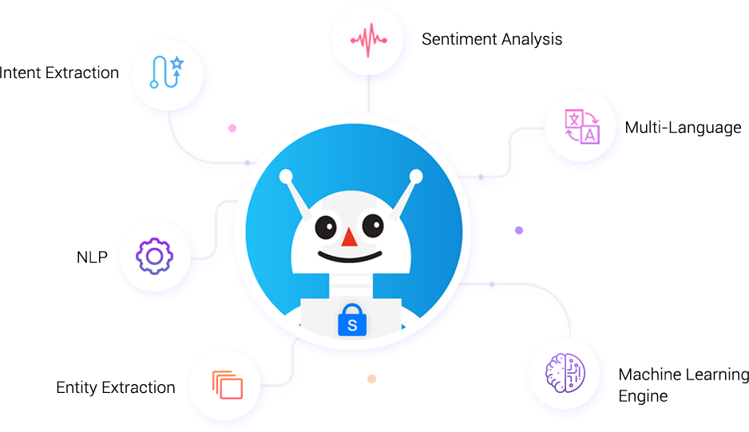

* SnatchBot eliminates complexity and helps you to build the best chatbot experience for your customers. We provide robust administrative features and enterprise-grade security to comply with regulatory mandates.
* With our Omni-channel platform, SnatchBot’s tools support the entire lifecycle of a bot, from developing and testing to deploying, publishing, hosting, tracking and monitoring and include NLP, ML and voice recognition. The platform provides robust administrative features, scalable and enterprise-grade security that comply with all regulatory mandates.

1. **Create**

You can create an automated (bot) or Human (Human Hybrid) chatbot. No coding or technical skills required.

1. **Build**

Design conversations to utilise "Simple" or "Multiple Choice" or something more complex such as action buttons, translation, collect payments, send receipts and more. No coding or technical skills required.

1. **Publish**

Publish your bot everywhere your users are. No coding or technical skills required.

## 8.1 Natural language processing

* Enrich digital experiences by introducing chatbots that can hold smart, human-like conversations with your customers and employees. Use our proprietary, Natural Language Processing capabilities that enable chatbots to understand, remember and learn from the information gathered during each interaction and act accordingly.

## 8.2 Snatchbot Platform Features

* From front to back end processes, modernize your business functions with an easy-to-use platform with no coding skills required. We’re proud to say that no matter what the use case, our chatbots offer features that cover every eventuality.
* Premium interactions. Search interaction type. Await Response/Live chat. Extraction type interactions. PayPal. Broadcasting.
* Conversation History, Synonym, Sentiment Analysis. Natural Language Processing, Logic operations.
* Hand-off to an agent, Plugins. JSON API, Custom variables, Connections.

# FlowXo

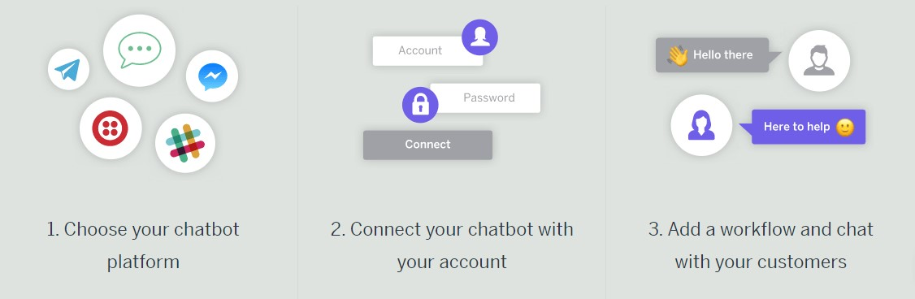Fig. 9.1 FlowXo Workflow

* FlowXo is a powerful automation product that allows you to quickly and simply build incredible chatbots that help you to communicate and engage with your customers across a wide range of different sites, applications and social media platforms.
* The ‘intelligence’ behind a FlowXo chatbot is created using a powerful workflow, and you can have an infinite number of these running in your chat window. This means your chatbot can be any or ALL of the above at the same time.

## 9.1 How does Flow XO work?

### 9.1.1 Create your chatbot

* Choose how you want to interact with your customers. You can choose one platform or make yourself available on all.

### 9.1.2 Build your workflows

* Using our drag and drop editor, you build your workflow and then connect it to one or more of your platforms.

### 9.1.3 Integrate your apps

* Optionally, you can connect your workflows with over 100 different cloud-based apps. For example, you could add an email address from a chat directly to your Mail Chimp distribution list.

## 9.2 Flow Xo Platform Features

* Provide a virtual welcome mat to your business. Welcome new visitors by providing a friendly greeting before guiding them through your site.
* Gather information.
* Answer simple questions.
* Pre-filter leads.
* Live Chat.
* Accept payments via your chatbot.
* Provide light-hearted entertainment.

# Chatteron

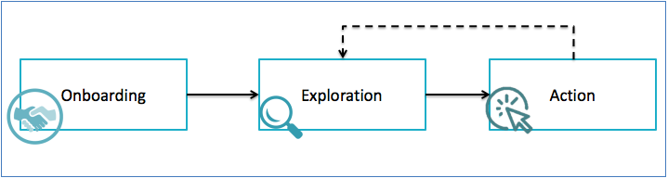

* At ChatterOn we strive to make it super easy to deploy bots within minutes.
* Chatbots are conversational agents which can help you engage your customers and increase your revenues many fold! You can also use chatbots as the first layer of customer support and help you save up to 75% costs!
* ChatterOn is an AI chatbot platform that focuses on providing accessible yet powerful tools that anyone can use. You don't have to know how to code to use ChatterOn (I don’t), and you don’t even have to have previous experience with chatbots (I had only a little). You’ll have everything you need right within the ChatterOn software.

## 10.1 ChatterOn Platform Features

* The majority of marketing chatbot builders looks more or less the same. They have a typical left-sidebar layout and dedicate most of the screen space to the tab you currently have open.
* They also tend to approach bot building in a block-based fashion, where you create blocks of content within a specific tab.
* But ChatterOn takes a different approach from most chatbot programs.
* ChatterOn has several other features that help you build chatbots, but the visual editor serves as the centre of it all. This is where you’ll be creating your dialogues and arranging your conversational paths.
* Each module can be moved around the grid so you can lay things out exactly how you want. This is a nice touch that gives you a lot of freedom to modify the layout, which is something that no other platform really offers.

## 10.1.1 Easy to build

* Sign Up and deploy an AI powered chat-bot within a few minutes directly on the cloud.

## 10.1.2 Monetize

* Start monetizing your chatbot from day one with contextual & relevant advertisement from Radbots.

## 10.1.3 Bot Builder

* Build custom and engaging conversational experiences while controlling the final outcome

## 10.1.4 End-to-end Solution

* From setting up AI to building the user flow, everything can be achieved.

## Rich Content

* Our platform supports rich content payloads like carousels, buttons, photos, gifs and videos.

## Business Integration

* Connect your existing backend APIs with our chat-bot platform for easy and seamless integration.

# Flowchart Diagram

## 11.1 Corona Virus Information Chatbot

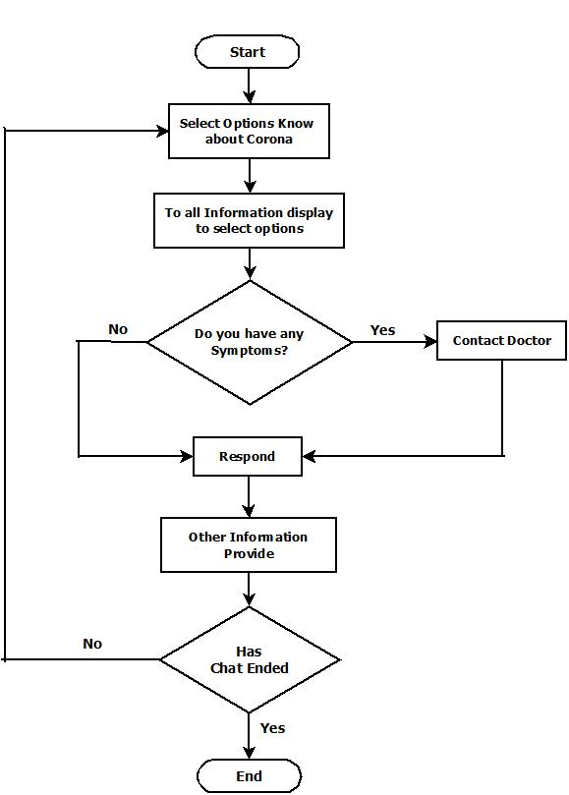

## Government Exam Chatbot

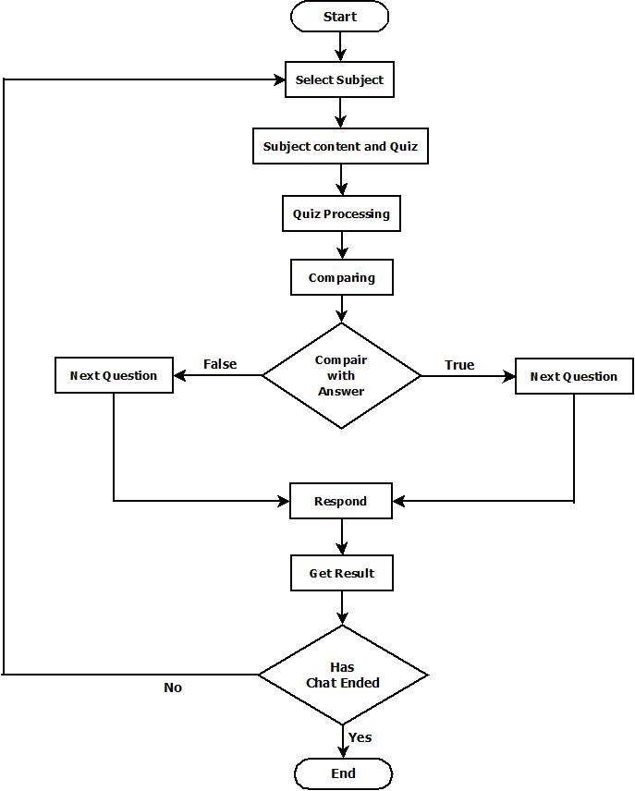

## E-Commerce

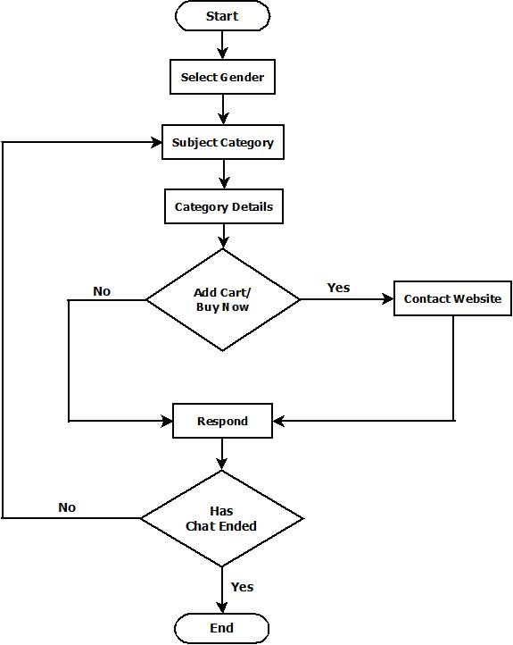

## College Enquiry Chatbot

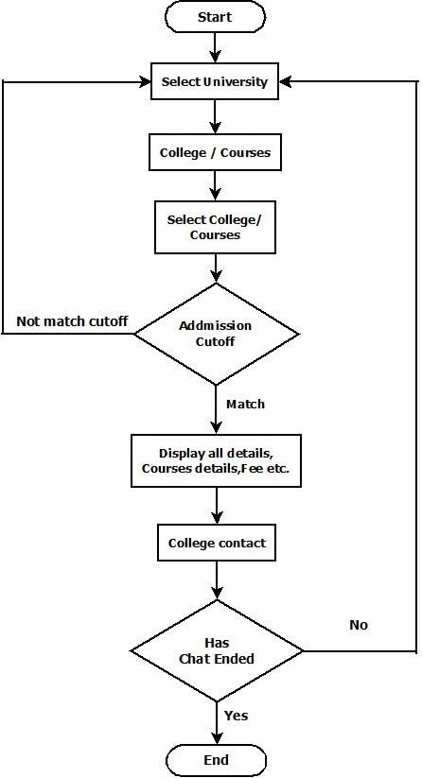

## Latest News Feeder Chatbot

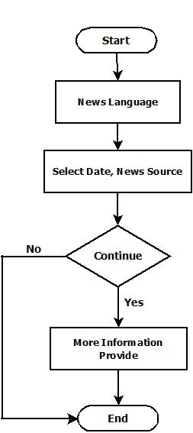

# 12. System Design

## 12.1 Corona virus Information Chatbot

### 12.1.1 Home Page



Fig.12.1.1 Dashboard Page

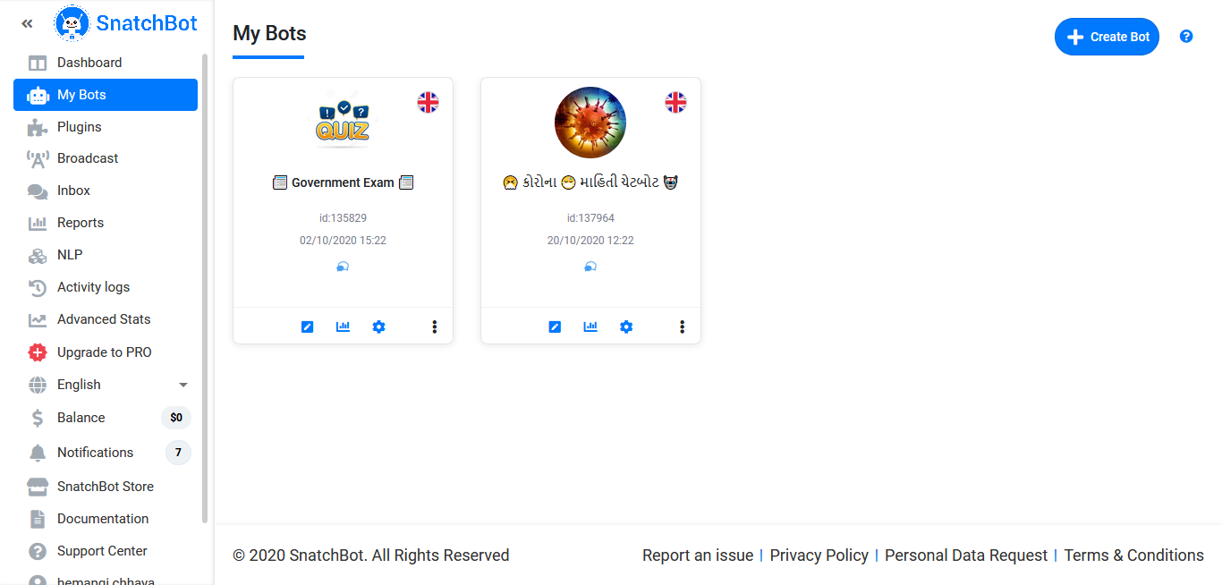

Fig.12.1.2 Front Page

### 12.1.2 Starting Page

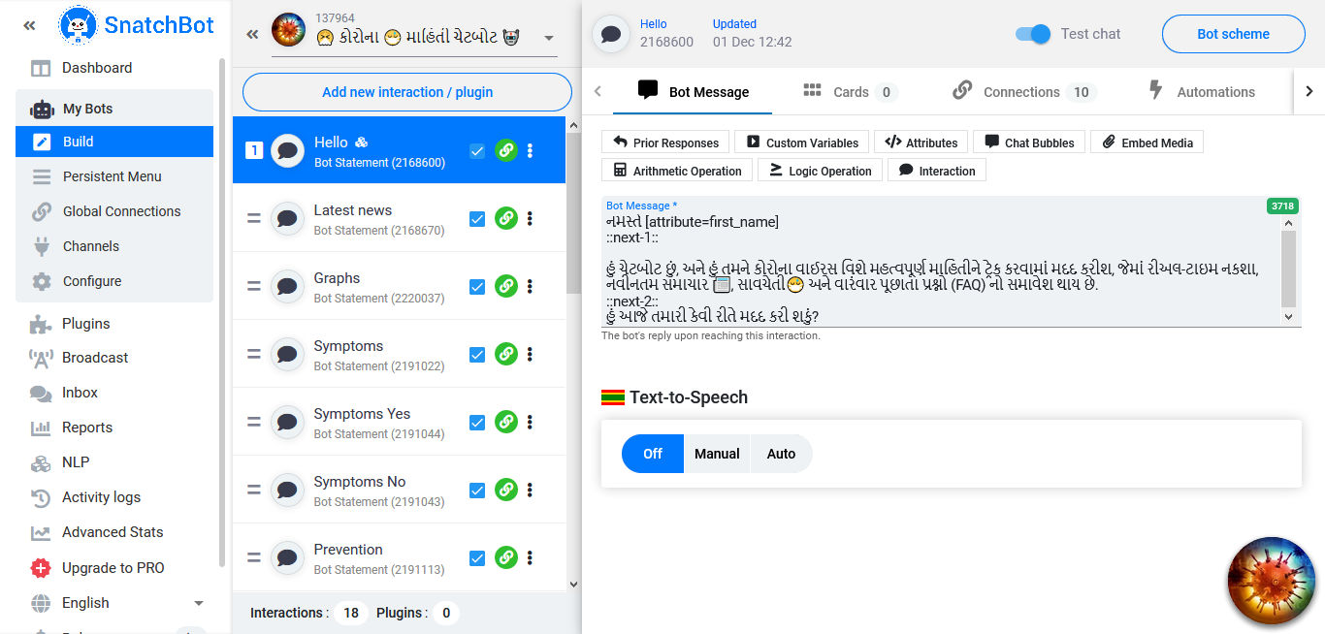

Fig.12.1.3 Front Page

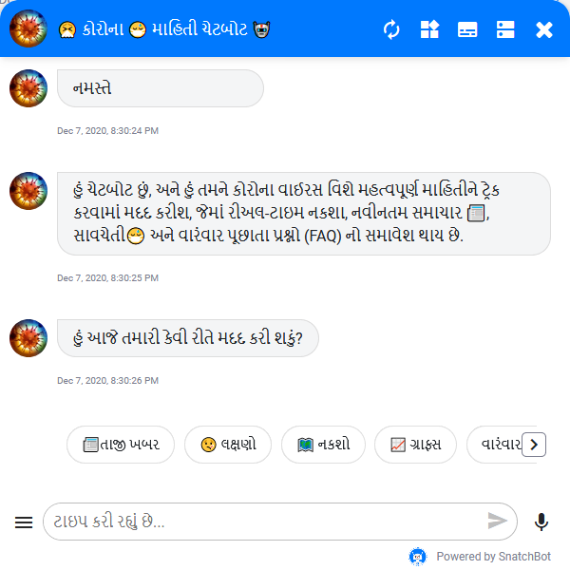Fig.12.1.3 Information Page

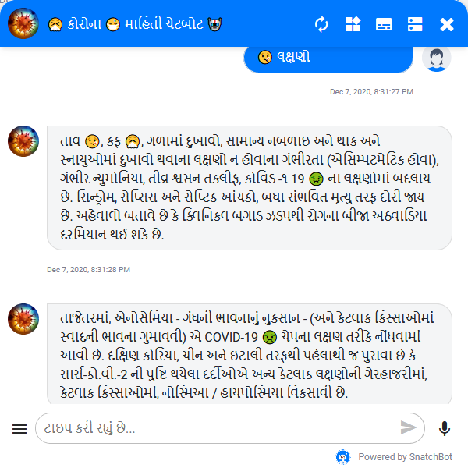

Fig. 12.1.4 Symptoms Page

### 12.1.3 Ending Page

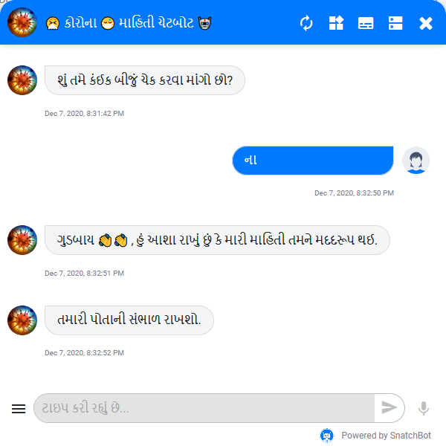

Fig. 12.1.5 Ending Page

## 12.2 Government Exam Chatbot

### 12.2.1 Home Page



Fig. 12.2.1 Front Page

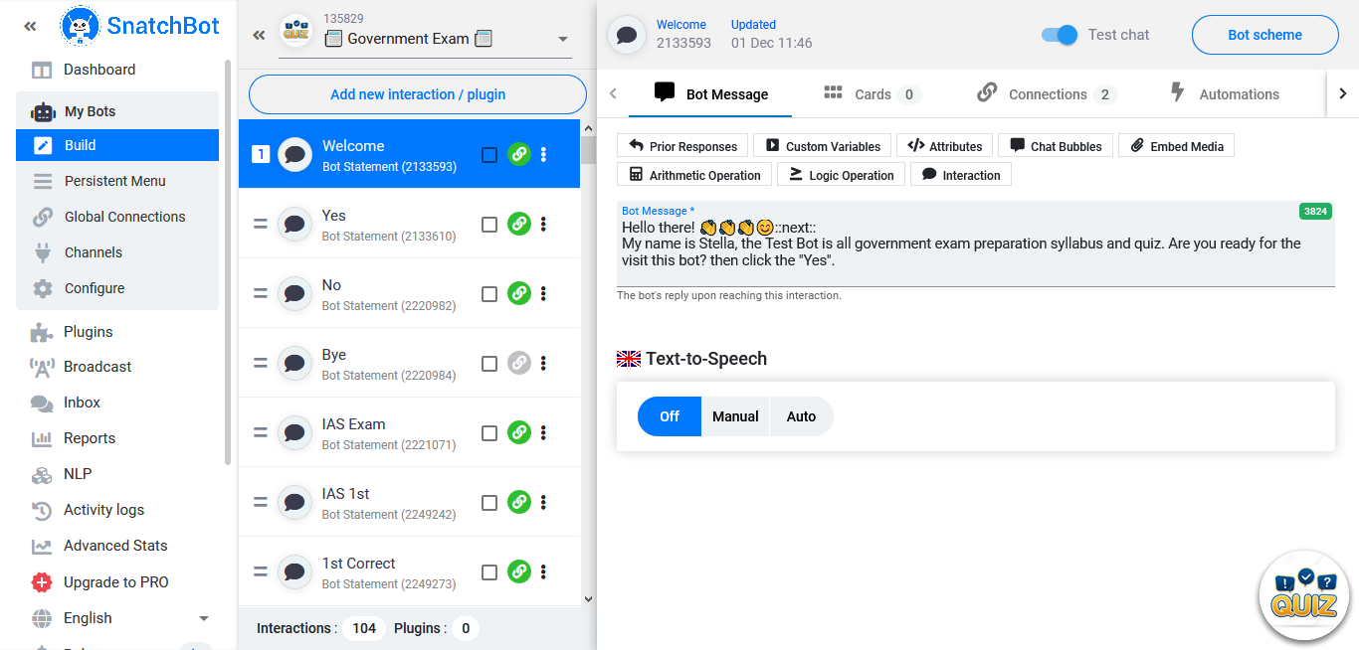

Fig. 12.2.2 Working Page

### 12.2.2 Starting Page

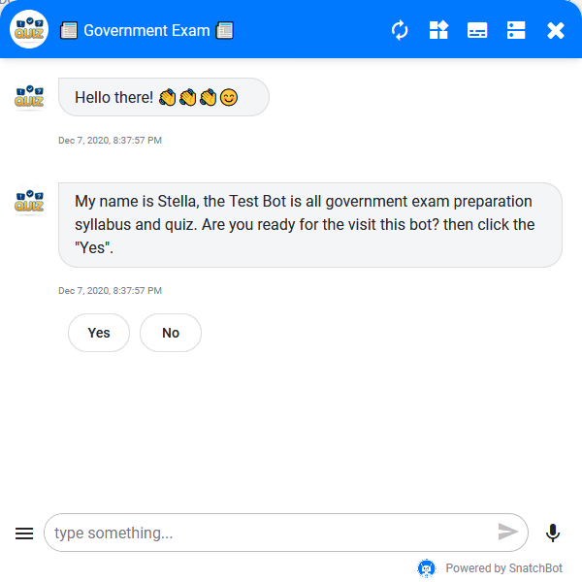

Fig. 12.2.1 Welcome Page

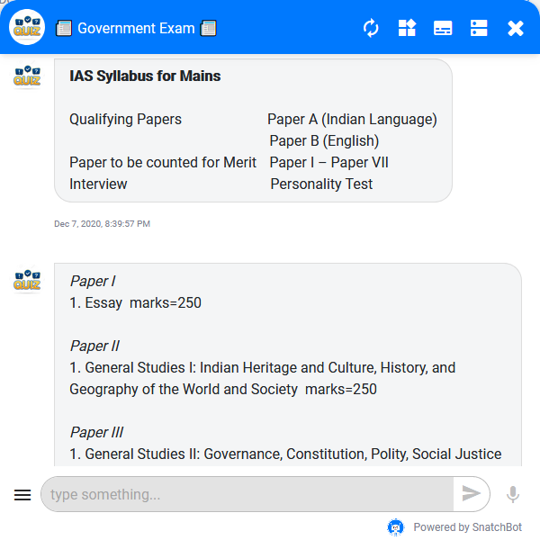

Fig. 12.2.1 Syllabus Page

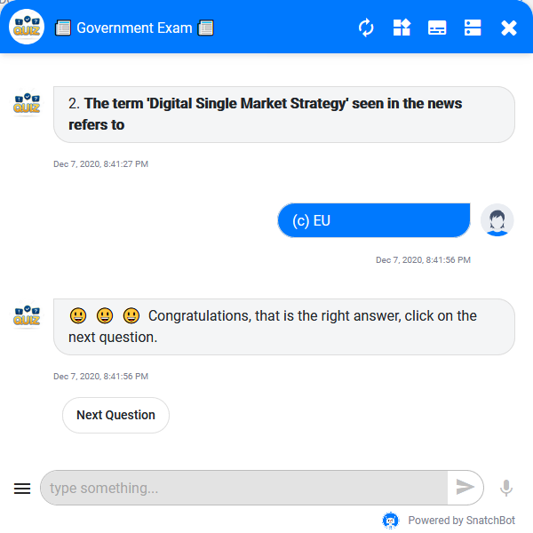

Fig. 12.2.1 Quiz Page

### 12.2.3 Ending Page

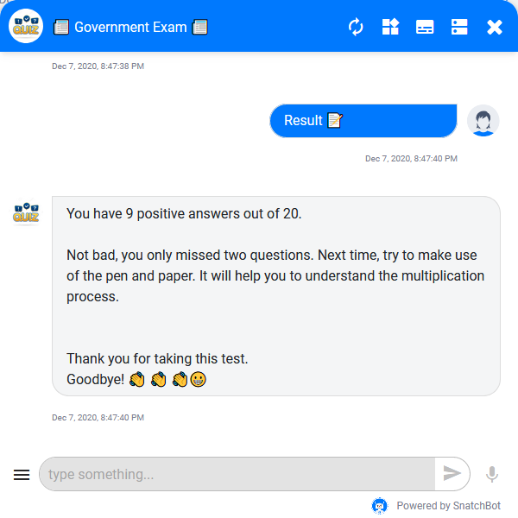

Fig. 12.2.1 Result Page

## 12.3 E-Commerce

### 12.3.1 Home Page

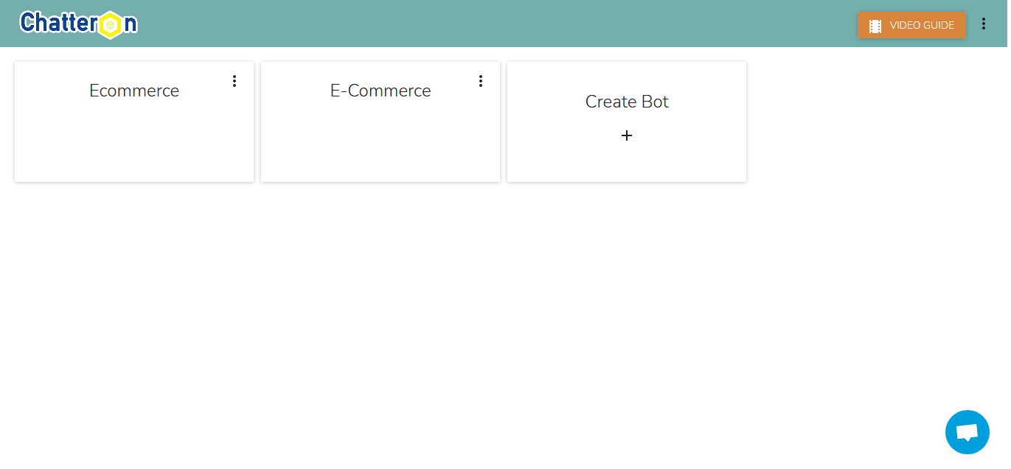Fig. 12.3.1 Front Page

### 12.3.2 Starting Page

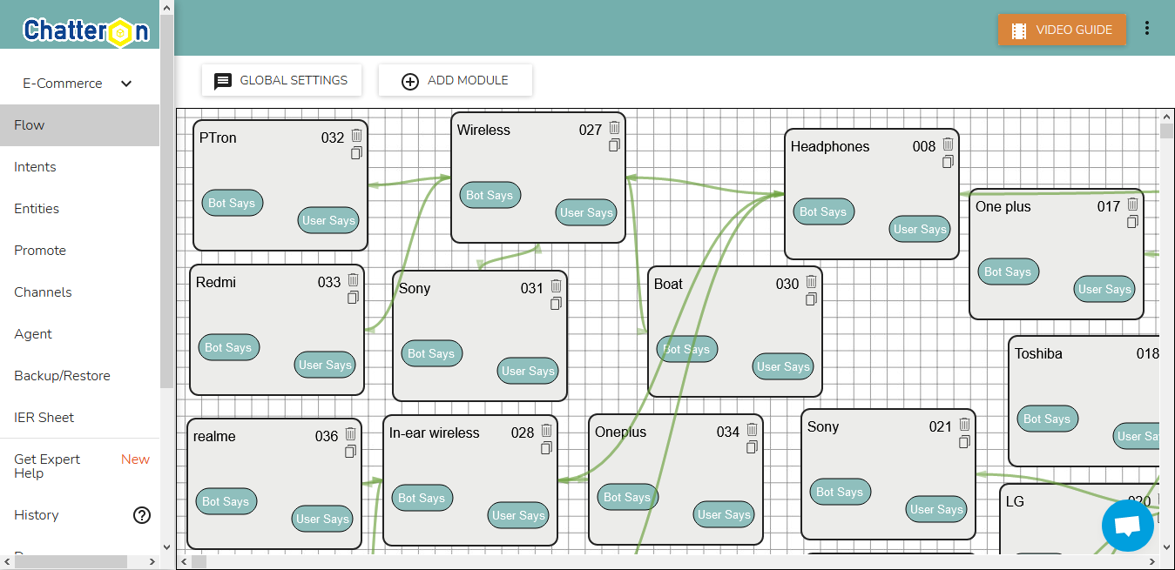

Fig. 12.3.2 Flow Page

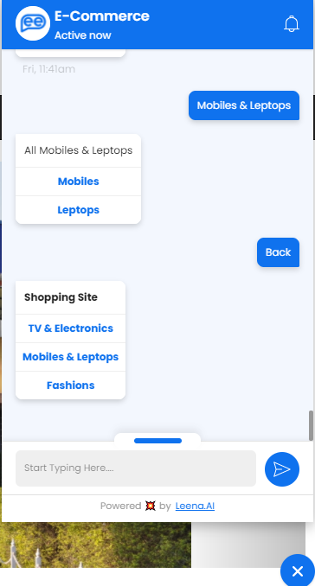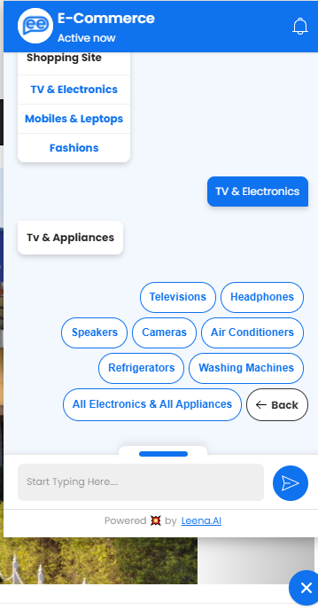

Fig. 12.3.4 Category Page Fig. 12.3.4 TV & Appliances Page

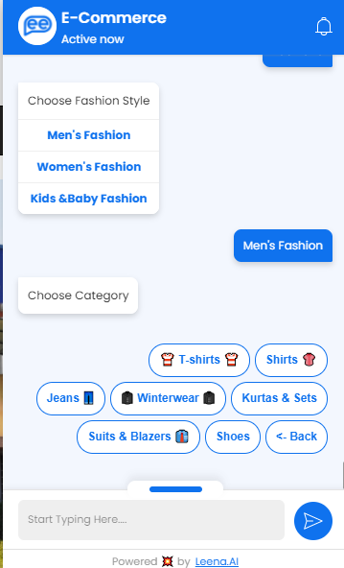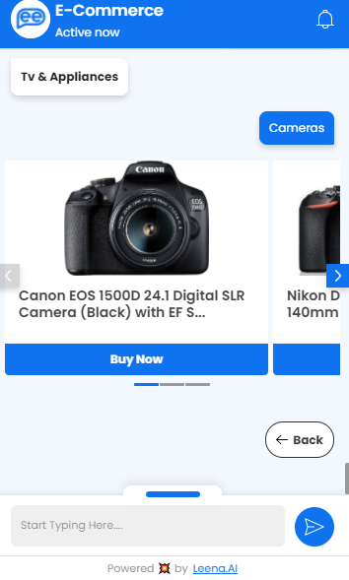

Fig. 12.3.5 Camera Page Fig. 12.3.6 Men’s Fashions Page

### 12.3.3 Ending Page

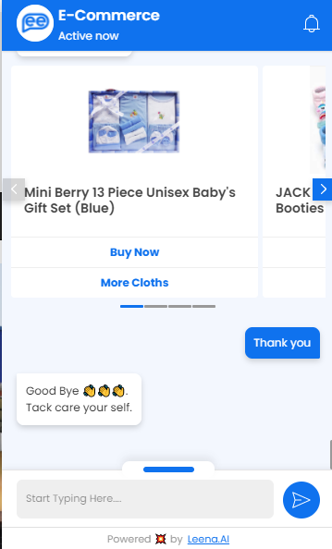

Fig. 12.3.7 Ending Page

## 12.4 College Enquiry Chatbot

### 12.4.1 Home Page

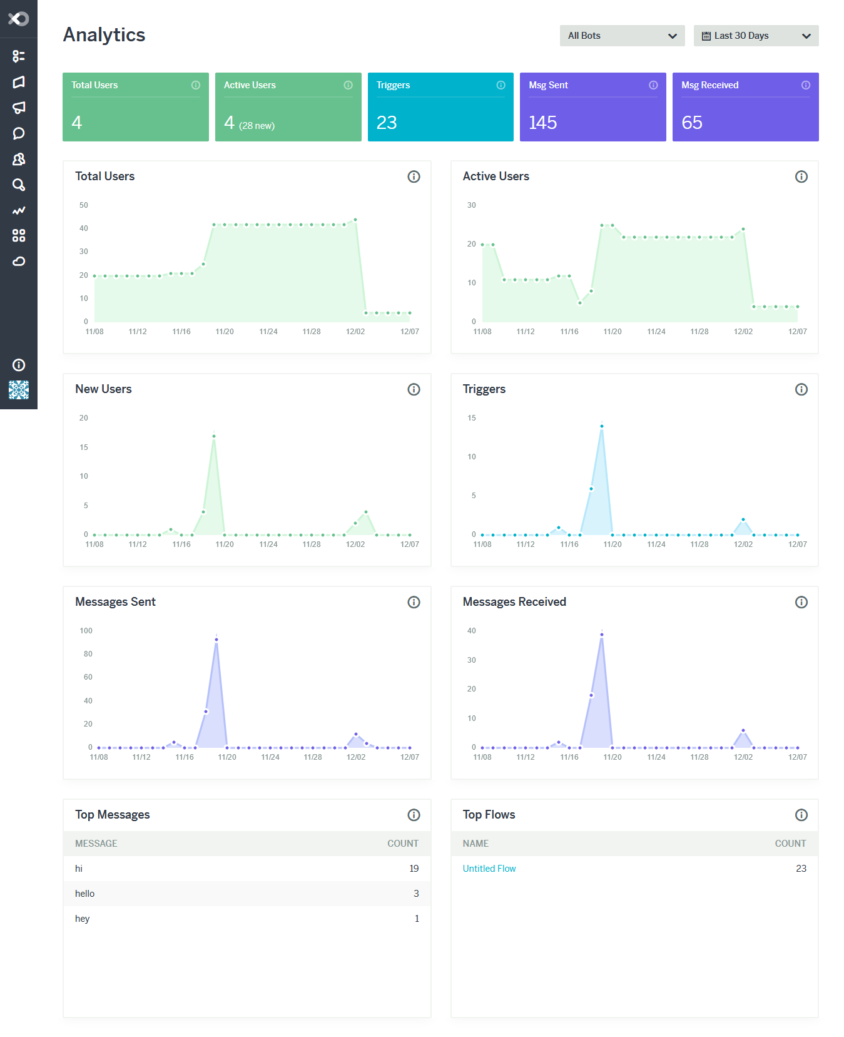

Fig. 12.4.1 Front Page

### 12.4.2 Starting Page

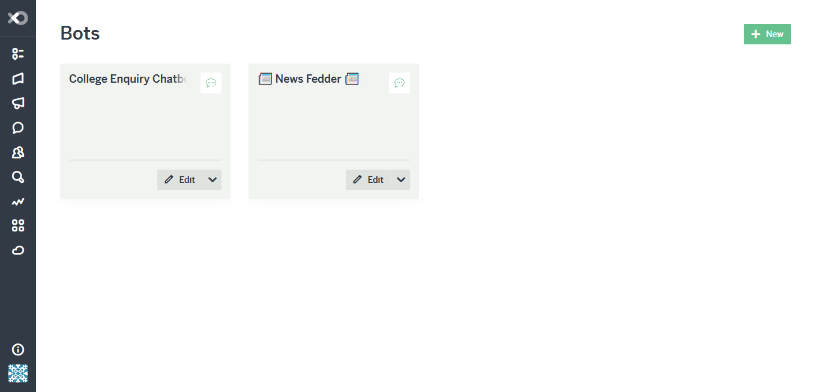

Fig. 12.4.2 Home Page

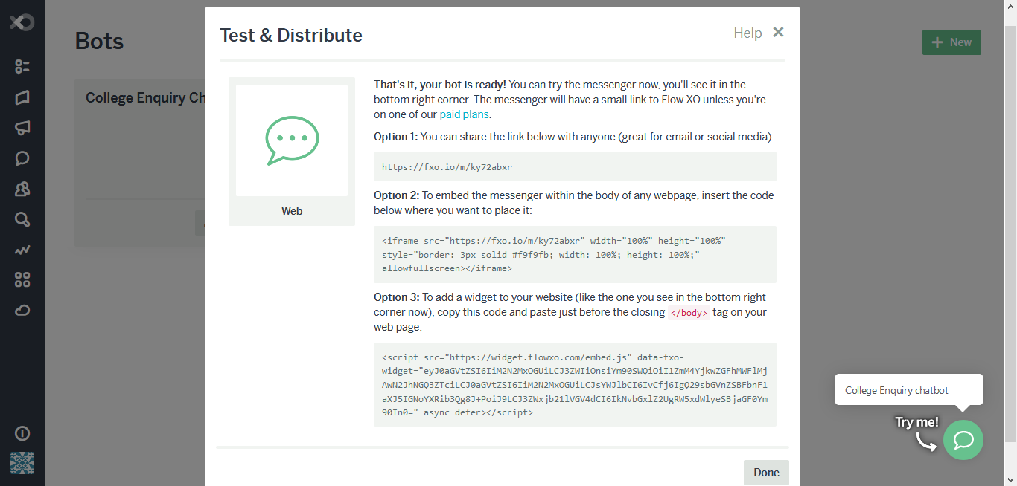

Fig. 12.4.3 Testing Page

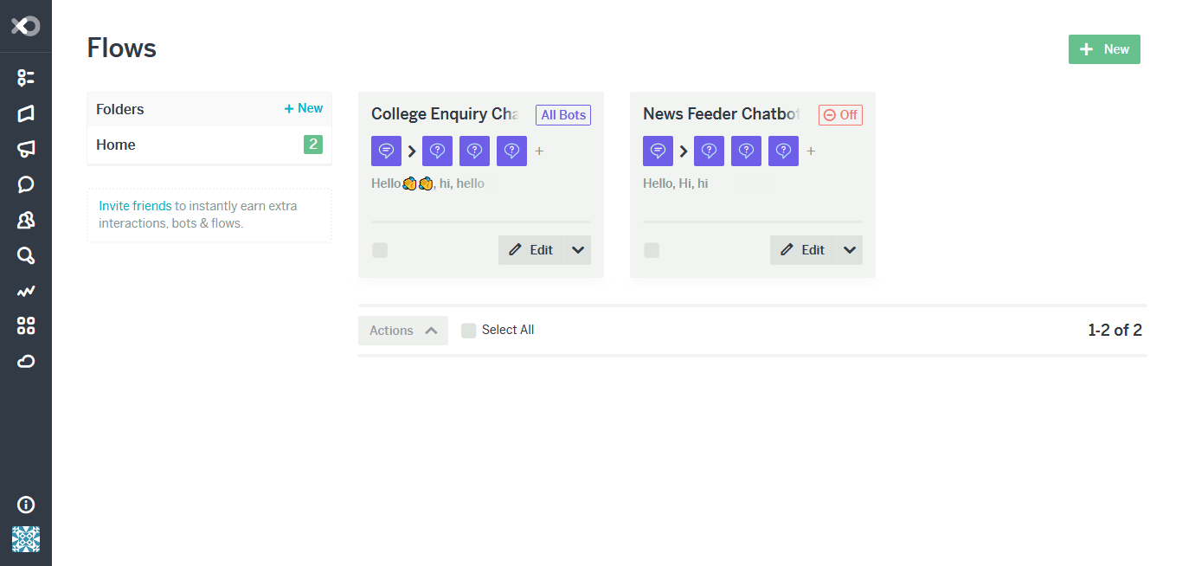

Fig. 12.4.4 Flow Page

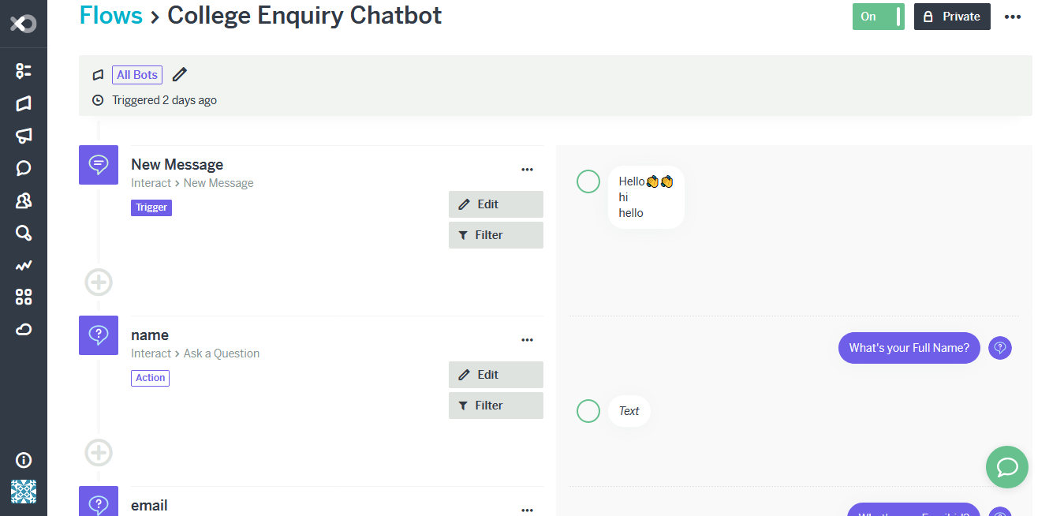

Fig. 12.4.5 College Enquiry Flow Page

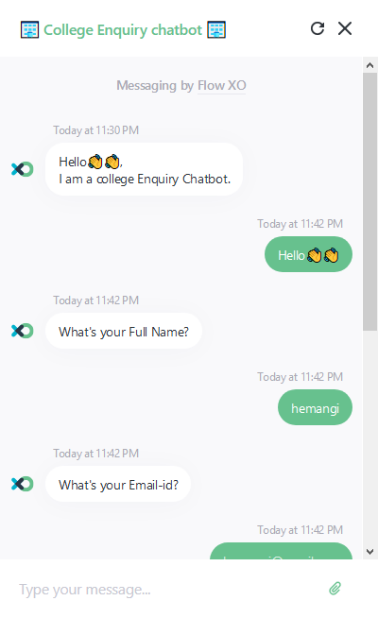 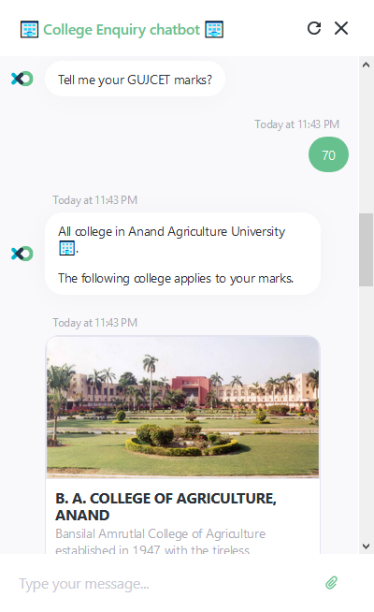

Fig. 12.4.6 Student Details Page Fig. 12.4.7 College Details Page

### 

### 12.4.3 Ending Page

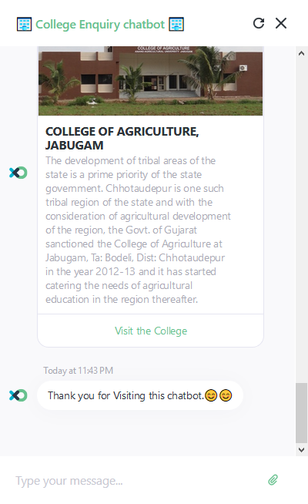

Fig. 12.4.8 Ending Page

## 12.5 Latest News Feeder Chatbot

### 12.5.1 Home Page



Fig.12.5.1 Home Page



Fig. 12.5.2 News Feeder Flow Page

### 12.5.2 Starting Page

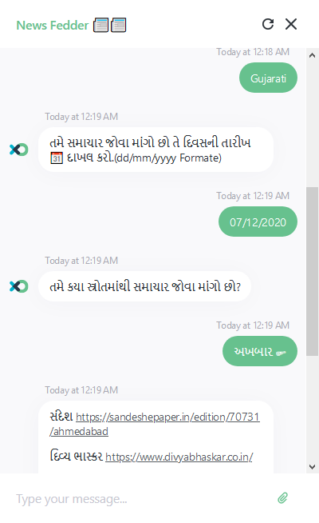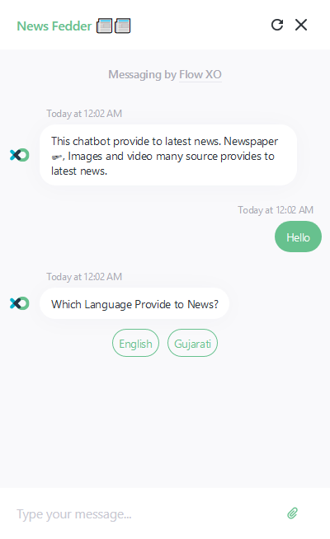

Fig. 12.5.3 Language Page Fig. 12.5.4 Guajarati News Paper Page

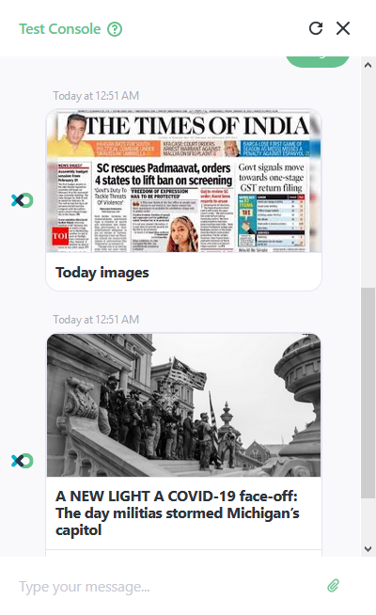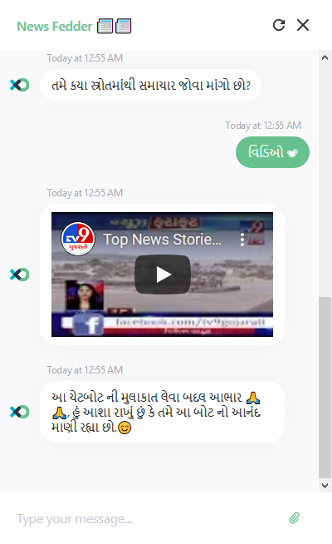

Fig. 12.5.5 English News Paper Page Fig. 12.5.6 Gujarati Video Page

### 12.5.3 Ending Page

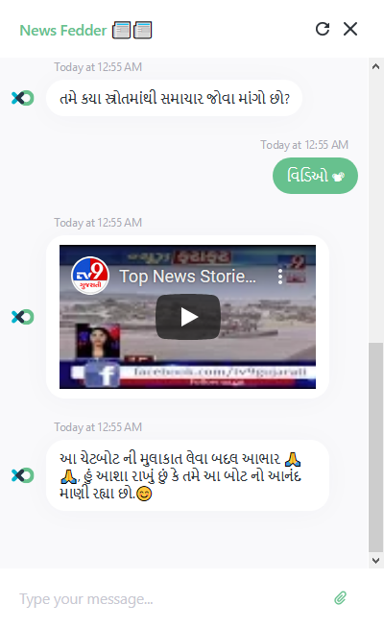

Fig. 12.5.7 Ending Page

# Conclusions

This work introduced the fundamentals of what chatbots are. It gave an overview about ideas, products and platforms, both, from the past and available today. The current interests in chatbots, potential use cases and limitations have been explored in detail. Different aspects of the implementation of a chatbot and working with conversational interfaces have been presented through the creation of an exemplary chatbot, which included interaction and user experience design, and general, reusable software architecture for chatbots. While not all aspects can be covered within the context of this work, the goal was to give an overview about what chatbots are, their use cases and how to create them. This knowledge should help exploring further possibilities of chatbot usage and it should enable more developers to apply chatbots to new scenarios and thereby also improve human-machine interaction in general.

# Reference

1. <https://flowxo.com/>
2. [chatbots.pdf (jorin.me)](https://jorin.me/chatbots.pdf)
3. <https://snatchbot.me/>
4. <https://snatchbot.me/features>
5. [DrexelChatbotSRS.pdf](http://www.cci.drexel.edu/seniordesign/2016_2017/DrexelChatbot/DrexelChatbotSRS.pdf)